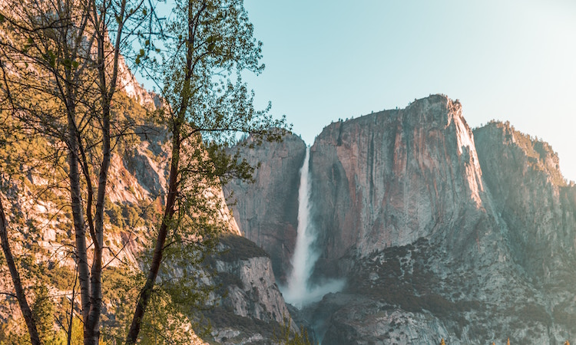

**Source is fictional**

Author

URL

Title

Date

https://www.parkphotos.com/yosemite/hullman208

Park Photos

Posted: 03/14/2017

Bridalveil Fall

Photography by Jaylen Hullman